Northstar Analytics
CECL Suite v4.2
Model Monitoring & Governance Guide
Document ID: NA-CECL-MON-4.2
Release Date: February 17, 2026
Confidential - For Client Governance & Monitoring Use Only

Prepared by: Northstar Analytics, Model Support & Governance Enablement
Primary contacts: modelsupport@northstaranalytics.example | governance@northstaranalytics.example
Intended users: Client Model Owners, Model Risk Management, Finance Close Reviewers, Data Stewards

Document Control
Version | Date | Author | Reviewer | Summary of Changes
1.0 | 2025-10-01 | M. Patel | R. Chen | Initial monitoring framework and sample KPI catalog
1.1 | 2025-12-20 | M. Patel | R. Chen | Added drift thresholds; expanded override governance
1.2 | 2026-02-17 | M. Patel | R. Chen | Refined SR 11-7 alignment matrix; added escalation paths and evidence checklists

Distribution and Use
This guide describes a vendor-recommended monitoring and governance approach for the Northstar CECL Suite. It supports establishing repeatable monitoring routines, defining thresholds, documenting exceptions, and maintaining evidence for model risk management. This document is written in a vendor governance enablement format and is not aligned to client model documentation templates.

Table of Contents (Generated in Word)
Placeholder for Word-generated Table of Contents. To update: References > Table of Contents > Update Table.
1. Purpose, Scope, and Definitions
2. Monitoring & Governance Workflow
3. Monitoring Cadence and Minimum Expectations
4. Data Quality & Data Drift Monitoring
5. Model Performance Monitoring (PD/LGD/EAD/Lifetime ECL)
6. Scenario Governance (Macro Inputs and Weights)
7. Overrides, Qualitative Adjustments, and Management Overlays
8. Thresholds, Escalation, and Issue Management
9. Model Change Management and Release Governance
10. Evidence, Auditability, and Retention
11. Roles, RACI, and Operating Committees (Vendor Terminology)
12. Regulatory Alignment Matrix (Illustrative)
Appendices (Sample Pack, KPI Dictionary, Templates, Glossary)

1. Purpose, Scope, and Definitions
Purpose: define a structured monitoring program for the CECL Suite supporting data integrity, stability checks, output review, exception handling, and evidence retention.
Scope: monitoring of inputs (data and scenarios) and outputs (ECL metrics and drivers), thresholds and escalation, issues and changes, and evidence retention. This guide complements client governance policies.

1.1 Key Definitions (Vendor)
Term | Definition
Monitoring Pack | Monthly set of KPI tables, variance views, and exception logs supporting close sign-off.
Exception | Deviation from rules/thresholds requiring review and documentation.
Override | Controlled adjustment within configuration per client governance.
Overlay | Management adjustment outside model output.
Drift | Distributional shift in drivers or mix that may affect performance.

2. Monitoring & Governance Workflow
Monitoring is integrated with the close run: pre-run QC and drift screening, post-run reasonableness and variance checks, documented exception handling, and archiving of evidence bundles.
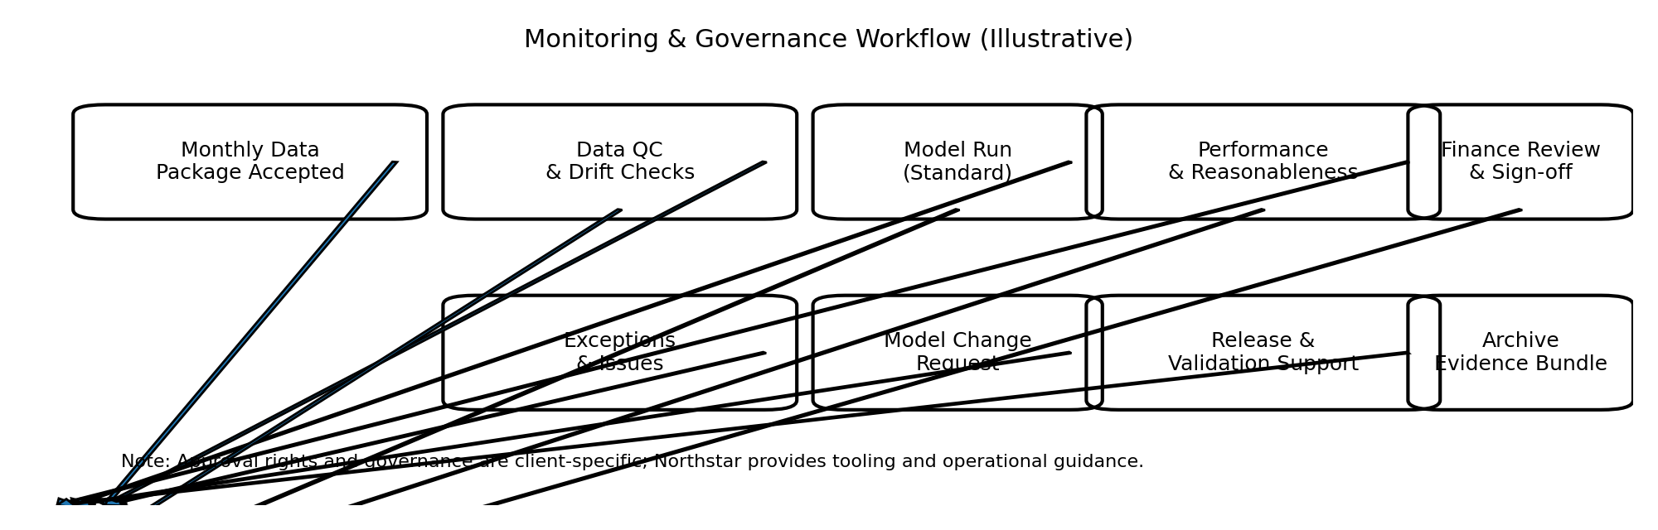

3. Monitoring Cadence and Minimum Expectations
Frequency | Monitoring Activities | Primary Owner | Outputs
Monthly (Close) | QC, drift screening, output variance checks, override log updates | Data Steward / Finance Reviewer | Monitoring pack + sign-off
Quarterly | Threshold recalibration review; segmentation stability review | Model Owner / MRM | Quarterly monitoring memo
Annually | Performance assessment, benchmarking, documentation refresh | Model Owner / MRM | Annual assessment
Ad hoc | Event-driven reviews due to portfolio or policy changes | Model Owner | Event memo

Exhibit: Example KPI Snapshot
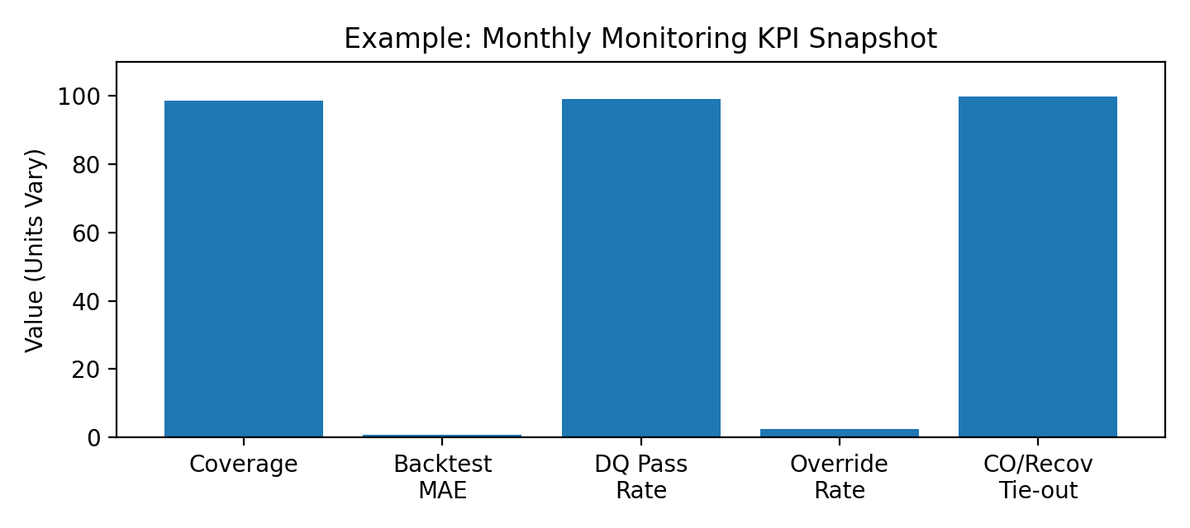

4. Data Quality & Data Drift Monitoring
- Schema/required fields completeness by segment.
- Uniqueness/referential integrity for keys and joins.
- Range and validity checks (e.g., DPD bounds, non-negative balances).
- Aggregate balance movement checks vs transactions and charge-offs/recoveries.

Exhibit: PSI Trend (Illustrative)
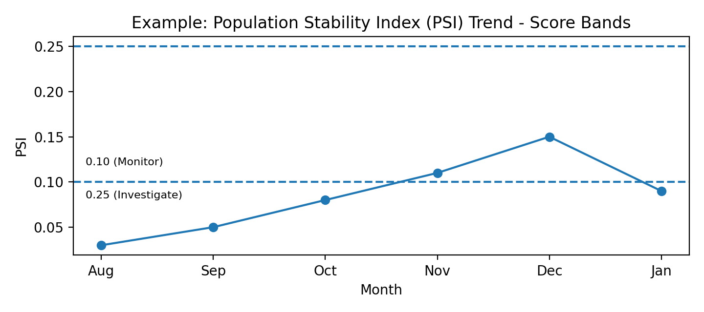

4.1 Example Thresholds
Area | Green | Amber (Monitor) | Red (Investigate)
PSI (driver) | < 0.10 | 0.10–0.25 | > 0.25
Segment mix shift | < 3% abs | 3–8% abs | > 8% abs
Missingness (key field) | < 0.5% | 0.5–2.0% | > 2.0%
Balance reconciliation | < 0.5% var | 0.5–1.0% | > 1.0%

5. Model Performance Monitoring (PD/LGD/EAD/Lifetime ECL)
- Segment ECL variance vs prior period with attribution (balance, PD, LGD, scenario).
- Distribution stability of PD/LGD/EAD by segment (mean/median, tail checks).
- Constraint checks: PD/LGD in [0,1], EAD non-negative, discount factors monotonic.
- Outcome proxies: short-horizon realized losses, roll rates, and vintage diagnostics where applicable.

5.1 Trigger Events for Enhanced Monitoring
- Acquisitions/sales or core system conversions.
- Material underwriting/collections changes.
- Macroeconomic regime change or forecast volatility.
- Policy changes impacting charge-off/recovery recognition.

6. Scenario Governance (Macro Inputs and Weights)
Scenario selection and weighting are client decisions. The vendor supports ingestion, mapping, versioning, and traceability of scenario artifacts.
Artifact | Description | Evidence Example
Scenario package | Macro time series (baseline/adverse/etc.) | Source citation + checksums
Scenario mapping | Series mapping to model drivers | Mapping workbook version
Weights memo | Approved weights and rationale | Finance/MRM memo
Reversion settings | Horizon and method | RUN_CONTROL snapshot

7. Overrides, Qualitative Adjustments, and Management Overlays
Category | Example | Governance Control
Data override | Correct segment override for known misclassification | Exception memo + approval + effective dates
Parameter override | Temporary LGD floor for stressed segment | Change ticket + impact analysis + sunset date
Segmentation override | Move accounts to workout segment | Policy alignment + exception log
Post-model overlay | Qualitative adjustment for emerging risk | Overlay memo + approvals + persistence monitoring

7.1 Purpose and Rationale Framework for Adjustments and Overlays
Post-model adjustments and overlays exist to address factors that the quantitative model is not designed or calibrated to capture fully. The CECL Suite model produces estimates that reflect historical experience, current portfolio characteristics, and macroeconomic scenarios — but it cannot independently identify or respond to emerging risks, structural portfolio changes, or idiosyncratic conditions that fall outside the scope of the model’s design. Overlays and parameter adjustments allow management to incorporate this additional information in a transparent, governed, and auditable manner.
Recognized categories of circumstances that may justify an overlay or adjustment include: (i) known portfolio composition changes not yet reflected in model calibration (e.g., acquisition of a loan book with materially different underwriting standards); (ii) recent changes to charge-off, collection, or servicing policy that break the historical relationship between observable drivers and realized losses; (iii) identified concentration risk not captured by current segmentation (e.g., geographic exposure to a localized economic shock such as a single employer closure or natural disaster); (iv) management’s view that the selected macroeconomic scenario set understates or overstates risk relative to information available at the reporting date; and (v) low-default segments where statistical estimation is inherently uncertain and expert judgment supplements the quantitative output. Overlays must not be used to systematically bias results in a particular direction across periods without supporting evidence, and should be expected to converge toward zero as the underlying condition becomes incorporated in model parameters or recalibration.

7.2 Override and Overlay Documentation Requirements
Every override, parameter adjustment, and post-model overlay applied in a given reporting cycle must be individually documented in the Override and Overlay Log maintained by the model owner. The log is a living document updated at each close cycle and reviewed by model risk management on a quarterly basis. Each log entry must include the following minimum fields:
Identification: Override/overlay ID, type (data override, parameter override, segmentation override, or post-model overlay), affected component (PD, LGD, EAD, or segment-level ECL), and affected as_of_date(s). Description: Plain-language description of the adjustment, including direction (upward or downward) and magnitude expressed both as an absolute ECL amount and as a percentage of unadjusted ECL at the affected segment and portfolio level. Rationale: The specific business or risk management reason for the adjustment, citing observable evidence (e.g., data, news, policy memo, audit finding) that supports the direction and magnitude. The rationale must distinguish between adjustments supported by quantitative analysis and those primarily reflecting qualitative judgment. Approval: Name, title, and date of signature of the approving authority (typically the model owner for parameter overrides and the Finance Reviewer for post-model overlays, with model risk management notification for any overlay exceeding 2% of total portfolio ECL). Duration: The planned start date, end date or sunset trigger (e.g., "until next recalibration" or "until two consecutive quarters of normalized loss rates"), and a review frequency for persistence assessment. Impact: Cumulative ECL impact of all active overlays relative to the unadjusted model output, reported as a dollar amount and percentage at the portfolio level and by major product.
The Override and Overlay Log is included as a standing agenda item at the quarterly ACL/ALLL Committee. At each quarterly review, the committee confirms that each active override or overlay remains appropriate given current conditions, and documents this confirmation. Overlays that have been active for more than four consecutive quarters without a quantitative basis being incorporated into the model are escalated to model risk management for evaluation of whether recalibration or a model change is warranted. The log is retained as part of the permanent evidence bundle alongside the run metadata for each reporting period.

7.3 Override Frequency Tracking and Reporting
Override and overlay frequency is tracked as a model health metric in its own right. Persistent or escalating override activity may indicate that the model’s quantitative estimates are no longer reliably capturing portfolio risk dynamics, which would support a recalibration or validation review. The following metrics are reported in the quarterly monitoring memo and the annual model performance assessment:
Override Rate: Percentage of total portfolio balance subject to an active override or overlay in the current period (override_bal / total_bal). A rate consistently above 5% of total portfolio balance warrants model owner review of whether the override reflects a systemic model limitation requiring recalibration. Override Persistence: Number of consecutive reporting periods for which each overlay has been active. Overlays active for more than four consecutive quarters are flagged for escalation review. Directional Bias: Aggregate direction of all active overlays (net upward or net downward ECL impact). Persistent net-upward overlays may indicate the model is systematically underestimating risk in the current environment; persistent net-downward overlays may indicate over-conservatism and should be reviewed with equal rigor. Impact Trend: Period-over-period change in total overlay impact as a percentage of unadjusted ECL. A growing overlay impact in the same direction across multiple periods is a trigger for enhanced monitoring and potential recalibration review. These metrics align to the KPI Dictionary in Appendix B (Override Rate KPI) and are included in the monitoring pack submitted to the ACL/ALLL Committee.

8. Thresholds, Escalation, and Issue Management
Tier | Trigger | Required Action | Decision Owner (Typical)
Tier 0 (Info) | Green KPI movement | Record in pack | Run Operator
Tier 1 (Monitor) | Amber breach | Commentary; monitor next period | Model Owner
Tier 2 (Investigate) | Red breach or repeated amber | RCA; remediation plan | Model Owner + Data Steward
Tier 3 (Governance) | Material impact or policy breach | Committee review; consider rerun/overlay | MRM / Finance Committee

8.1 Issue Lifecycle (Vendor)
- Detect
- Triage
- Remediate
- Validate
- Close

8.2 Recalibration and Retuning Triggers and Process
Recalibration is the process of updating model parameters — most commonly PD and/or LGD scalers, hazard shape parameters, or macro coefficient weights — to realign modeled outputs with observed portfolio experience, without changing the underlying model methodology. Recalibration is distinct from a model change (which alters methodology or segmentation) and from an overlay (which adjusts outputs outside the model). The following events trigger a mandatory evaluation of whether recalibration is warranted; the evaluation itself does not require recalibration to be performed, but the conclusion must be documented and reviewed by model risk management.
Trigger 1 — Back-Test Failure: Modeled loss rate deviates from realized net charge-off rate by more than 25% on a relative basis (e.g., modeled 1.00% vs. realized 1.30%) for two or more consecutive quarters for any major segment. This threshold aligns to the segment stability thresholds defined in the Methodology and Model Development Report (Section 4.3). When a back-test failure persists for two consecutive quarters, a recalibration evaluation memo is due to model risk management within 30 days of the second observation.
Trigger 2 — Population Stability Breach: PSI for any key input variable exceeds 0.25 (Red threshold) for two or more consecutive periods, indicating material distributional shift relative to the development population. A PSI breach does not automatically require recalibration — the model may remain appropriate despite distributional shift if the variable relationship to default is stable — but the evaluation must consider whether the shift invalidates the variable coefficient or the calibration window used to estimate the model.
Trigger 3 — Sustained Overlay Activity: Any post-model overlay that has been active for more than four consecutive quarters with a directionally consistent ECL impact (see Section 7.3). Sustained overlays are a signal that the quantitative model is not capturing a systematic factor, which may be better addressed through recalibration than through permanent overlay maintenance.
Trigger 4 — Scheduled Annual Review: Regardless of whether any of the above triggers have fired, a recalibration evaluation is performed as part of the annual model performance assessment. This review considers the full set of monitoring metrics for the year and produces a written conclusion: either (a) no recalibration warranted, with supporting rationale; (b) recalibration recommended, with proposed scope and timeline; or (c) further analysis required, with a defined completion date. The annual recalibration evaluation is provided to the independent model validator as part of the ongoing monitoring documentation.
Recalibration Process: When recalibration is determined to be warranted, Northstar performs the recalibration using the client’s historical performance data (supplemented by consortium data where client history is limited). The process involves: (i) defining the calibration window (typically the most recent 4 to 8 quarters of realized charge-off and recovery data); (ii) estimating updated calibration scalers or hazard parameters to minimize the difference between modeled and realized loss rates over the calibration window; (iii) testing the recalibrated parameters on a held-out out-of-time validation window to confirm that the update improves fit without overfitting to the calibration period; and (iv) comparing ECL outputs from the recalibrated model to the current production model on the most recent run data to quantify the impact of the recalibration. Recalibration is implemented as a configuration update (minor version increment) and follows the release workflow in the Production Runbook (Section 4.2 of Document NA-CECL-OPS-4.2). Recalibration that changes model parameters requires model owner approval and model risk management notification, and the updated parameters are retained in the configuration snapshot for all subsequent runs.

8.3 Comparison to Northstar Developer Monitoring
In addition to the client-level monitoring described in this guide, Northstar Analytics conducts its own ongoing monitoring of model performance across the full client base using aggregated and anonymized portfolio data. Northstar’s monitoring program serves a different but complementary purpose to client monitoring: it assesses whether model performance is holding at the population level and identifies whether any observed issues are idiosyncratic to a specific client or systemic across the portfolio.
Northstar’s developer monitoring covers: (i) quarterly diagnostic review of PD discrimination metrics (AUC and KS statistic) aggregated across all contributing client portfolios, segmented by product type; (ii) calibration stability monitoring comparing modeled loss rates to realized charge-off rates across vintage cohorts on a rolling basis; (iii) PSI for key input variables (score bands, utilization, DPD distribution) computed against the original development dataset; and (iv) macro scenario realization review, comparing the macro paths assumed in prior-period runs to subsequently observed economic data to assess systematic forecast bias. Results are published in Northstar’s quarterly Model Health Report, which is distributed to all clients. Clients should compare their institution-specific monitoring results to the Northstar portfolio-wide benchmarks included in the Model Health Report to assess whether any observed deviations are institution-specific or reflect industry-wide trends.
Key differences between client-level and developer-level monitoring: Client monitoring is institution-specific, uses the client’s actual unmasked data, and is performed by or on behalf of the model owner with governance accountability to the ACL/ALLL Committee and model risk management. Developer monitoring is population-level, uses anonymized aggregated data, and is performed by Northstar with the objective of maintaining and improving the CECL Suite for the client base as a whole. Developer monitoring does not substitute for client monitoring and cannot satisfy SR 11-7 ongoing monitoring requirements, which require institution-specific performance assessment. However, the quarterly Model Health Report provides important context for interpreting client-level results, particularly for low-default segments where the client’s own loss history may be insufficient to draw statistically reliable conclusions independently. If Northstar’s developer monitoring identifies a deterioration in model performance for a specific product type that affects the client’s portfolio, Northstar will notify affected clients and provide a remediation plan as part of the model support process.

9. Model Change Management and Release Governance
Change Type | Examples | Minimum Controls
Vendor release | Bug fixes, algorithm improvements, new exports | Release notes + UAT + baseline comparisons
Config change | Thresholds, scenario mapping, segmentation tables | Ticket + approvals + UAT
Mapping/ETL change | New field or sign convention change | Parallel load + reconciliation + QC sign-off
Emergency hotfix | Production defect requiring immediate patch | Break-glass approvals + post-incident review

10. Evidence, Auditability, and Retention
- Inputs/outputs/config snapshots with checksums and run identifiers.
- Monitoring packs and variance commentary.
- Exception/override/overlay logs and approvals.
- Change tickets, UAT results, and release notes.
Artifact Type | Recommended Retention | Notes
Inputs/Outputs/Config snapshots | >= 7 years | Align to financial reporting retention requirements
Monitoring packs | >= 7 years | Supports trends and examinations
Issue tickets | >= 3 years | Retain longer for recurring themes
Approvals/committee materials | Per client policy | Often aligned to corporate governance retention

11. Roles, RACI, and Operating Committees (Vendor Terminology)
Activity | Run Operator | Data Steward | Model Owner | Finance Reviewer | MRM
Monthly QC review | C | R | C | I | I
Reconciliations | I | R | C | C | I
Scenario approval | I | I | C | R | C
Variance commentary | C | C | R | R | C
Override approval | I | C | R | R | C
Material change control | C | C | R | C | R

11.1 Designated Client-Side Resources and Responsibilities
Effective ongoing governance of the CECL Suite requires designated individuals in specific roles on the client side. Northstar recommends that the following positions be formally documented and approved by senior management, with named backups identified for each role to ensure continuity during absences or transitions. Designations should be reviewed and re-confirmed annually as part of the model governance documentation refresh.
Model Owner: The designated business owner accountable for the model’s fitness for purpose, appropriate use, and ongoing governance. Typically a senior officer in Finance, Credit Risk, or the CFO organization. Responsibilities include: approving scenario selections and weights, reviewing and approving the quarterly monitoring memo and annual performance assessment, authorizing recalibration requests, approving all material changes, and presenting the model to the ACL/ALLL Committee. The model owner is the primary point of accountability for model risk management and external examiners.
Data Steward: The designated owner of data quality, extraction, reconciliation, and data certification. Typically a senior analyst or manager in Finance, Data Engineering, or Controllership. Responsibilities include: overseeing automated and manual data extractions, completing and signing the monthly data certification memo, resolving Critical and High QC findings before each run, maintaining the mapping workbook, and managing re-deliveries for data corrections. The Data Steward is the primary contact for Northstar data onboarding and support on data-related issues.
Finance Reviewer: The designated approver for model outputs before use in financial reporting. Typically a senior member of the Finance close team. Responsibilities include: reviewing the run output package, completing the allowance rollforward reconciliation, approving the finance sign-off memo, and presenting ECL results to the CFO and ACL/ALLL Committee. The Finance Reviewer also approves scenario weights and post-model overlays that affect the reported allowance.
Model Risk Management (MRM) Representative: The designated MRM contact responsible for independent oversight of the model. Typically a model risk officer or senior analyst in the model risk function. Responsibilities include: reviewing the quarterly monitoring memo, assessing recalibration determinations, overseeing annual performance assessments, and coordinating independent validation. MRM does not execute model runs or approve operational outputs; its role is oversight and challenge.
Run Operator: The designated technical operator responsible for executing the model run, monitoring job completion, and coordinating with Northstar support on operational issues. Typically in IT Integration, Data Engineering, or a model operations function. The Run Operator role carries no approval authority and must not be combined with the Finance Reviewer or Data Steward roles in steady-state production (segregation of duties requirement per Section 3.3 of Document NA-CECL-OPS-4.2).

11.2 Required Background, Experience, and Staffing Change Protocols
Northstar recommends that individuals in the model owner, MRM representative, and Finance Reviewer roles possess sufficient quantitative literacy to critically evaluate model outputs, challenge management overlays, and assess the reasonableness of period-over-period ECL changes. This does not require a technical modeling background, but does require familiarity with credit loss concepts, the CECL accounting standard, and the institution’s portfolio risk profile. Recommended minimum background for each role:
Model Owner: Senior-level experience in credit risk, finance, or accounting, including direct familiarity with allowance estimation under CECL or a predecessor standard (ALLL). Experience presenting model results to senior management and external auditors is expected. Northstar recommends that new model owners complete Northstar’s Model Owner Orientation (a four-hour virtual session covering model architecture, governance obligations, and common challenge scenarios) within 90 days of designation.
Data Steward: Practical experience with data extraction from core banking or loan servicing systems, familiarity with GL reconciliation processes, and comfort with SQL or equivalent querying tools. Experience with data quality assurance programs is beneficial. The Data Steward should understand the business meaning of each required field in the canonical schema and be capable of identifying and escalating plausible data anomalies without Northstar intervention.
MRM Representative: Background in model risk management, quantitative risk, or a related analytical discipline. Familiarity with SR 11-7 / OCC 2011-12 model risk management guidance and experience conducting or overseeing model validation activities. The MRM representative should be capable of independently assessing monitoring metrics, challenging recalibration conclusions, and determining when an independent validation review is required.
Staffing Change Protocols: Significant staffing changes in any of the designated roles must be managed to protect continuity and avoid control gaps. Northstar defines a significant staffing change as: departure, extended leave (more than 30 days), or role elimination of the primary designee without an identified and trained backup in place; or simultaneous changes in two or more designated roles within a 90-day period. When a significant staffing change occurs, the following steps apply: (i) the departing individual completes a formal knowledge transfer to the successor or backup, documented in writing and retained in the model governance file; (ii) the successor completes applicable orientation (Northstar Model Owner Orientation if taking the model owner role); (iii) the model owner notifies Northstar Client Services of the change and updates the designated contact list in the client record; and (iv) the change is disclosed to model risk management and noted in the next quarterly monitoring memo. If a critical role (model owner or Data Steward) is vacated without a trained successor in place, Northstar may recommend deferral of the next scheduled production run until continuity is restored, to avoid control gaps in the sign-off and certification process.

12. Regulatory Alignment Matrix (Illustrative)
Illustrative mapping to common model risk governance themes; clients should align to internal policy and applicable guidance. This is not legal advice.
Governance Theme | Typical Expectation | Guide Coverage | Example Evidence
Ongoing monitoring | Track performance and stability over time | Sections 3–5 | Monitoring packs; trend KPIs
Data integrity | Ensure inputs are accurate and complete | Section 4 | QC reports; reconciliations
Change control | Controlled changes with testing and approvals | Section 9 | Tickets; UAT results
Override governance | Transparent and justified overrides/overlays | Section 7 | Override logs; approvals
Documentation & auditability | Support review and re-performance | Section 10 | Evidence bundles; snapshots

Appendix A: Sample Monthly Monitoring Pack Outline
- Executive summary and approvals
- Input QC and reconciliations
- Drift dashboard and commentary
- Output variance and attribution
- Exceptions, overrides, overlays log
- Scenario confirmation and reversion settings
- Appendix: detailed tables and extracts

Appendix B: KPI Dictionary (Excerpt)
KPI | Definition | Calculation | Suggested Threshold | Notes
Input coverage | % accounts with required fields | 1 - missing/total | >= 98% | By segment and total
Balance tie-out | Variance vs control total | |model-control|/control | < 0.5% | Investigate structural diffs
PSI (score) | Distribution shift vs baseline | PSI on bins | < 0.10 | Monitor at 0.10; investigate at 0.25
ECL variance | Change vs prior period | (ECL_t - ECL_t-1)/ECL_t-1 | Client-defined | Use attribution
Override rate | % balances affected | override_bal/total_bal | Client-defined | Track persistence

Appendix C: Templates (Printable)

C.1 Exception Memo Template (Outline)
- Exception ID and date
- Description and impacted portfolios/segments
- Detection method and threshold trigger
- Root cause assessment
- Disposition (fix/accept/rerun/overlay)
- Impact quantification (ECL delta)
- Approvals and signatures
- Follow-up actions and prevention

C.2 Change Request Template (Outline)
- Change summary and classification
- Rationale and expected impact
- Testing plan and acceptance criteria
- Baseline comparison results
- Implementation and rollback plan
- Approvals and implementation window

Appendix D: Glossary
Term | Definition
ECL | Expected credit loss output (typically lifetime for CECL).
PSI | Population Stability Index; measure of distribution shift.
MRM | Model Risk Management function.
QC | Quality control checks on inputs/outputs.
UAT | User acceptance testing environment.

Appendix E: Recalibration Evaluation Checklist and Documentation Template
This checklist supports the preparation of a recalibration evaluation memo, which is required when any of the triggers in Section 8.2 are observed or when the annual review is due. The memo is submitted to model risk management and retained in the permanent model governance file. The checklist does not prescribe a recalibration conclusion; it ensures that the evaluation is systematic and that the conclusion is supported by evidence.

E.1 Trigger Identification
- Identify which trigger(s) initiated this evaluation: back-test failure, PSI breach, sustained overlay, or annual scheduled review.
- State the as_of_date(s) on which the trigger condition was first observed and the number of consecutive periods it has persisted.
- Identify the affected segment(s) and product type(s).

E.2 Performance Evidence Review
- Present the trailing 4- to 8-quarter back-test table for the affected segment(s): modeled loss rate vs. realized net charge-off rate by period, including the relative deviation and whether it exceeds the 25% threshold.
- Present PSI trends for the three to five most important input variables for the affected segment(s), including current PSI and the trend over the past four quarters.
- Summarize overlay history for the affected segment(s): number of periods active, direction, magnitude, and whether the overlay has been directionally consistent.
- Compare institution-specific results to the Northstar quarterly Model Health Report benchmarks for the same product type. Note whether the deviation is institution-specific or consistent with population-wide trends.

E.3 Root Cause Assessment
- Assess whether the performance deviation is attributable to: data quality issues (incorrect inputs), scenario or macro forecast error (macro path diverged materially from realization), model limitation (the model does not capture a systematic factor), or portfolio structural change (underwriting, servicing, or composition shifted beyond model design range).
- If the root cause is data quality or scenario error, remediation should focus on those inputs rather than recalibration. Document why recalibration is or is not the appropriate response given the identified root cause.

E.4 Recalibration Conclusion and Recommendation
- State the conclusion: (a) no recalibration warranted — provide rationale and confirm that the trigger condition is expected to resolve without intervention; (b) recalibration recommended — specify the proposed scope (which segments, which parameters), proposed calibration window, and expected timeline for Northstar to deliver recalibrated parameters; or (c) further analysis required — specify what additional data or analysis is needed and by when.
- If recalibration is recommended, state whether it is expected to constitute a material change (ECL impact above 5% at portfolio level) and whether an independent validation review will be triggered.
- Obtain model owner sign-off and model risk management review of the memo before submission to Northstar for recalibration engagement.

E.5 Post-Recalibration Validation
- Following recalibration, confirm that the recalibrated parameters have been delivered, reviewed, and implemented in accordance with the release process (Production Runbook Section 4.2).
- Run the back-test for the first two post-recalibration periods using the new parameters and confirm that the trigger condition has been resolved. Document the results in the next quarterly monitoring memo.
- If any overlay was maintained to address the same condition that drove recalibration, assess whether the overlay should be reduced or removed given the parameter update, and document the disposition in the Override and Overlay Log.

